Rosali Gonzalez

The game/puzzle is 3d to move each piece until it's on the spot. Based on the feedback received on the project proposal, I decided to increase the complexity and I add some more resources. Although, I haven’t finished the game my goal is moving it with mouse.

This is how you play the game

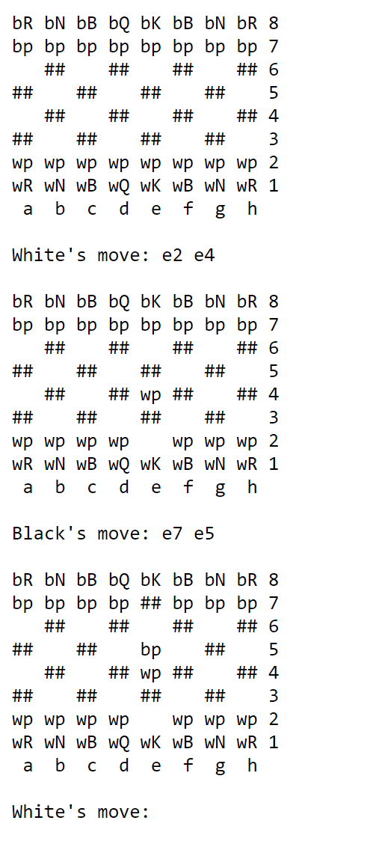

Black’s pieces start with B and white pieces start with W

In short when the white wants to play he will indicate where the piece he wants to play is and where he’s going to place the piece

So like at beginning he indicates e2 e4

So it take the piece that was at e2 and place it at e4

The rules I used are attached in the pdf